Put the title of the paper here with font Arial,
size 16pt, centered, length up to 2 lines

First + Middle (initial) + Last name∗1a(Superscript―*:Corresponding, 1:affiliation, a:footnote info),
Sullivan T. Smith^{*2}, Tanaka Ikarashi^{1a} and Ahmed M. Mohamed^{2b}

¹Affiliation (Department, Institute, Address, Country) with font Arial, size 9.5pt
²Department of Civil Engineering, Korean Advanced Institute for Science and Technology,
291 Daehak-ro, Yuseong-gu, Daejeon 305-701, Republic of Kiorea

Abstract (500 words max). This study aimed to develop a model to accurately predict the acceleration of structural systems during an earthquake. The acceleration and applied force of a structure were measured at current time step and the velocity and displacement were estimated through linear integration. ……

Keywords: complex terrain; typhoon wind field; CFD simulation; surface roughness length; topography

References (2 max)
Author(s) (Year), “Title of paper (Capital letter only for the first letter)”, Name of Journal (Italic), Volume number in bold(Issue number in non-bold), page-page.
Cheng, Y.F. (2011), “A comparison of large……”,Struct. Eng. Mech., 91(4), 1301-1328.

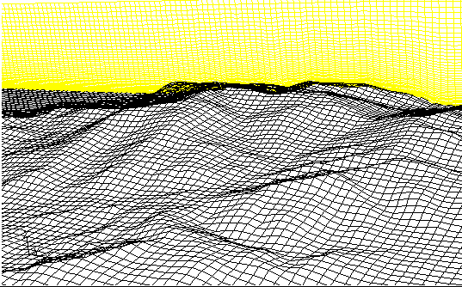
Fig. 1 Mesh grid of topographic model

∗Corresponding author, Professor (or Ph.D., etc.), E-mail: email address ª Ph.D., E-mail: email address ^{b} Ph.D. Student, E-mail: email address

